SIMATS ENGINEERING

CO3 - ASSESSMENT TOOL 3

Comparative Analysis

COURSE NAME: DEEP LEARNING COURSE CODE: MLA0408

COURSE OUTCOME COVERED

CO3: Students will be able to understand, analyze and apply CNN concepts including layers, filters, parameter sharing, regularization, AlexNet and ResNet for real-world image processing applications. (BTL-6)

CO Weightage: 25%
Assessment Tool Weightage: 40%

QUESTIONS: Total Marks:25

Q1. CNN vs Fully Connected Neural Network
A medical imaging organization wants to classify X-ray images using deep learning. Compare a CNN with a traditional fully connected neural network in terms of architectural design, motivation, spatial feature extraction, number of parameters, computational complexity, and ability to handle image data. Analyze the roles of convolutional layers, filters, and pooling layers, and justify why CNNs are more suitable for image classification applications.

Q2. Different CNN Layers and Filters
A manufacturing company is developing a CNN-based system to detect defects in industrial products. Compare the functions of convolutional layers, pooling layers, activation layers, and fully connected layers in terms of feature extraction, spatial information, computational requirements, and classification. Further compare early-layer filters and deeper-layer filters based on the type of features they learn, and justify how these layers collectively improve defect detection.

Q3. Parameter Sharing vs Independent Weights
A smart surveillance system needs to process thousands of high-resolution images efficiently. Compare parameter sharing in CNNs with independent weights in fully connected networks in terms of the number of parameters, memory requirements, computational complexity, feature detection, and translation-related invariance. Analyze how the reuse of convolutional filter weights improves learning efficiency and justify its importance for large-scale image-processing applications.

Q4. AlexNet vs ResNet
A computer vision company is developing an image classification system and is considering AlexNet and ResNet as possible architectures. Compare the two architectures in terms of network depth, layer organization, convolutional filters, parameter requirements, feature extraction capability, training difficulty, vanishing-gradient problem, computational cost, and classification performance. Recommend the more suitable architecture for a complex image recognition application and justify your choice.

Q5. Regularized CNN vs Non-Regularized CNN
An agricultural organization is developing a CNN to classify plant diseases from leaf images. The initial model achieves very high training accuracy but performs poorly on unseen images. Compare a CNN without regularization and a CNN using dropout, data augmentation, and batch normalization in terms of overfitting, generalization, training stability, computational requirements, and model performance. Analyze which regularization techniques should be applied and justify the most appropriate approach for reliable real-world disease classification.

Code of Conduct:

I K Sreelatha(192425248) (Name / Reg No) certify that this submission is my original work and that I have adhered to the guidelines specified for this assessment.
I understand that any violation of academic integrity rules will result in disciplinary action.

Signature of the student: 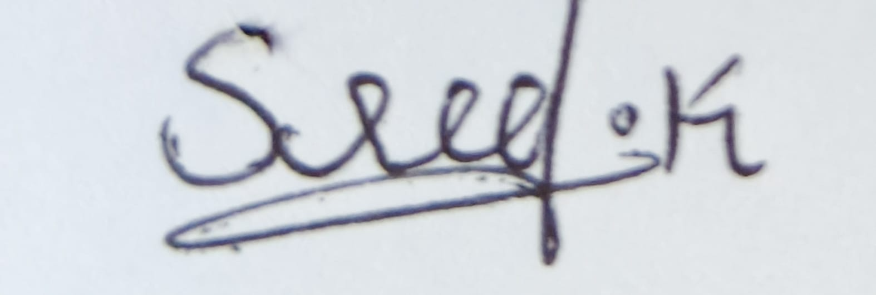

RUBRICS FOR CALCULATION:
Criteria | Weightage | Level 4 – Exemplary | Level 3 – Proficient | Level 2 – Developing | Level 1 – Beginning
Selection of Studies/Parameters | 20% | Selects highly relevant and diverse studies with well-defined comparison parameters | Selects relevant studies with minor gaps in parameter definition | Limited or partially relevant selection | Poor or inappropriate selection of studies
Comparison & Differentiation | 25% | Clearly compares multiple aspects (methods, results, limitations) with strong differentiation | Good comparison with minor gaps | Basic comparison with limited depth | No clear comparison; mostly descriptive
Critical Evaluation | 25% | Critically evaluates strengths, weaknesses, and implications with strong justification | Provides evaluation with some justification | Limited evaluation; lacks depth | No critical evaluation provided
Synthesis & Insight Generation | 20% | Generates meaningful insights and conclusions from comparisons | Some insights derived from comparison | Limited or unclear insights | No insights generated
Clarity | 10% | Information is clearly presented (tables/figures) with logical structure | Generally clear with minor issues | Presentation lacks clarity or structure | Poor presentation and difficult to understand

Q1. CNN vs Fully Connected Neural Network
A medical imaging organization wants to classify X-ray images. A Convolutional Neural Network (CNN) is more suitable than a traditional Fully Connected Neural Network (FCNN) because CNNs are specifically designed to process spatially structured data such as images.
1. Architectural Design
A traditional fully connected neural network connects every neuron in one layer to every neuron in the next layer. If an image is given as input, the image must usually be flattened into a one-dimensional vector.
For example, a grayscale image of size 224 × 224 contains:
pixels. If this is connected to just 1,000 neurons in the next layer, the number of weights is:
This produces a very large number of parameters.
A CNN, on the other hand, preserves the height, width, and channel structure of the image. It processes the image using convolutional filters and gradually learns important visual features.
2. Role of Convolutional Layers
A convolutional layer applies small filters or kernels over different regions of the image.
For example, a 3 × 3 filter moves across the X-ray image and performs mathematical operations with local pixels.
Different filters can learn different features such as:
- Edges
- Lines
- Curves
- Textures
- Shapes
- Abnormal regions
- Lesion-like patterns
In medical images, early convolutional layers may identify basic structures, while deeper layers combine these features to identify more complex abnormalities.
3. Spatial Feature Extraction
One major advantage of CNNs is that they preserve spatial relationships.
For example, in an X-ray:
- The location of bones matters.
- The shape of organs matters.
- The relationship between different structures matters.
- The position and shape of abnormal regions can be important.
A fully connected network loses much of this spatial structure when the image is flattened.
CNNs use local receptive fields, meaning each neuron initially focuses on a small region of the image.
4. Pooling Layers
Pooling reduces the spatial dimensions of feature maps.
Common pooling methods include:
- Max pooling
- Average pooling
For example, a 2 × 2 max-pooling operation selects the largest value from each 2 × 2 region.
Pooling provides:
- Reduced feature-map size
- Lower computational cost
- Reduced number of parameters in later layers
- Some tolerance to small changes in object location
- Reduced sensitivity to noise

5. Number of Parameters
CNNs use parameter sharing. The same filter is reused across different parts of the image.
For example, a 3 × 3 filter has only:
weights, plus possibly a bias.
The same filter can detect an edge anywhere in the image.
In a fully connected network, different connections generally have independent weights, resulting in significantly more parameters.
6. Computational Complexity
Although CNNs perform many convolution operations, parameter sharing and local connectivity make them much more efficient for images than a fully connected architecture with comparable representational capability.
Fewer parameters also mean:
- Lower memory requirements
- Less storage
- More efficient training
- Reduced risk of overfitting
7. Overall Comparison
Feature | CNN | Fully Connected NN
Input | Image structure preserved | Usually flattened
Spatial information | Preserved | Largely lost
Feature extraction | Automatic | Less specialized
Parameters | Relatively fewer | Very large for images
Weight sharing | Yes | No
Image suitability | Excellent | Poorer
Computational efficiency | High for images | Expensive for large images
Translation tolerance | Better | Poor
Overfitting risk | Lower with suitable design | Higher due to many parameters
Conclusion
CNNs are more suitable for X-ray classification because they automatically learn spatial and hierarchical features while using fewer parameters through local connectivity and parameter sharing. Convolutional layers extract features, pooling reduces dimensionality, and fully connected layers perform final classification. Therefore, CNNs are widely preferred for medical image classification tasks.

Q2. Different CNN Layers and Filters
A manufacturing company can use CNNs to detect defects such as cracks, scratches, holes, dents, discoloration, or irregular shapes in industrial products.
A CNN generally contains convolutional layers, activation layers, pooling layers, and fully connected/classification layers.
1. Convolutional Layer
The convolutional layer is primarily responsible for feature extraction.
A filter moves over the input image and produces a feature map.
For example:
Input image → Filter → Feature Map
Different filters detect different patterns.
A filter may learn to detect:
- Horizontal edges
- Vertical edges
- Diagonal edges
- Corners
- Textures
- Small cracks
The convolution operation reduces the need for manually designing features.
2. Activation Layer
After convolution, an activation function is generally applied.
The most common activation function in CNNs is ReLU (Rectified Linear Unit):
It converts negative values to zero while retaining positive values.
The activation layer introduces non-linearity, allowing the CNN to learn complicated patterns.
Without nonlinear activation functions, stacking many linear operations would still produce a fundamentally linear transformation.
3. Pooling Layer
Pooling reduces the spatial size of feature maps.
For example, max pooling selects the maximum value within a region.
Its advantages include:
- Reducing computation
- Reducing memory requirements
- Reducing feature-map dimensions
- Providing some tolerance to small shifts
- Helping prevent overfitting
However, excessive pooling can remove useful defect information, especially for tiny cracks or scratches.
4. Fully Connected Layer
After several convolution and pooling operations, the extracted features are used for classification.
For example, the final layer might classify a product as:
- Normal
- Crack
- Scratch
- Dent
- Corrosion
Modern CNNs may use global average pooling followed by a classification layer instead of large fully connected layers.
5. Early-Layer Filters
Early convolutional layers usually learn simple features.
Examples include:
- Edges
- Lines
- Corners
- Basic textures
- Color/intensity transitions
For an industrial product, an early filter may detect a sharp boundary corresponding to the beginning of a crack.
6. Deeper-Layer Filters
Deeper layers combine simpler features to learn more complex patterns.
For example:
Pixels → Edges → Textures → Crack patterns → Defect type
A deeper layer may recognize the overall structure of a crack rather than just an individual edge.

7. Comparison
Layer | Main Function | Spatial Information | Computational Requirement
Convolution | Feature extraction | Preserves spatial structure | Moderate/High
Activation | Adds non-linearity | Preserves feature-map dimensions | Low
Pooling | Dimension reduction | Reduces spatial information | Low
Fully Connected | Classification | Spatial structure mostly converted to feature representation | Can be high
8. How They Work Together
A typical defect detection process is:
Input product image
↓
Convolution
Detect basic patterns.
↓
ReLU
Introduce non-linearity.
↓
Pooling
Reduce dimensions.
↓
More convolution + ReLU
Detect increasingly complex defect patterns.
↓
Classification layer
Predict the defect category.
Conclusion
The different CNN layers perform complementary tasks. Convolutional layers extract visual features, activation functions introduce non-linearity, pooling reduces spatial dimensions and computation, and classification layers determine the final defect category. Early filters detect simple patterns, while deeper filters detect complex defect structures. Therefore, the complete CNN architecture can automatically learn useful representations for industrial defect detection.

Q3. Parameter Sharing vs Independent Weights
A smart surveillance system may need to process thousands of high-resolution images. In this situation, CNN parameter sharing provides a major advantage over fully connected networks.
1. Parameter Sharing
In CNNs, the same convolutional filter is applied to different regions of the image.
For example, suppose a CNN has a 3 × 3 filter:
weights plus one bias.
These same weights can detect a particular feature throughout the entire image.
If an edge appears on the left side or right side, the same filter can detect it.
2. Independent Weights in Fully Connected Networks
In a fully connected network, every input neuron generally has a separate weight for each connection.
For a large high-resolution image, this can produce millions of parameters even in the first layer.
This leads to:
- High memory usage
- Greater computation
- Longer training
- Greater risk of overfitting
3. Memory Requirement
CNN parameter sharing dramatically reduces the number of parameters.
For example, a convolution layer with 64 filters of size 3 × 3 and 3 input channels requires:
weights, excluding biases.
A fully connected layer connecting a large image directly to many neurons could require millions of independent weights.
4. Computational Complexity
Parameter sharing makes CNNs computationally efficient because the network does not need to learn a separate detector for every possible image location.
Instead, it learns a small number of useful filters and reuses them.
This is especially valuable when processing:
- Surveillance videos
- High-resolution images
- Large datasets
- Real-time camera feeds
5. Feature Detection
Parameter sharing allows a filter to detect the same feature in different locations.
For example, a filter trained to recognize an edge can identify an edge:
- At the top
- At the bottom
- On the left
- On the right
of the image.
This is called translation equivariance of convolution: when the input shifts, the corresponding feature map also shifts.
Pooling and other architectural mechanisms can provide some degree of translation tolerance/invariance, although CNNs are not perfectly invariant to all translations.
6. Learning Efficiency
Suppose the surveillance system contains thousands of images.
A CNN does not need to learn separate parameters for every location of a feature. The same filter can learn from many examples across many locations.
This means that the model can learn general visual patterns more efficiently.
7. Comparison
Feature | CNN Parameter Sharing | Fully Connected Independent Weights
Weight usage | Same filter reused | Separate weights
Number of parameters | Low | Very high for images
Memory | Lower | Higher
Training | More efficient | More expensive
Spatial information | Preserved | Largely lost after flattening
Feature detection | Location-flexible | Location-specific
Overfitting | Generally lower | Higher
Large image processing | Suitable | Expensive
Conclusion
Parameter sharing is one of the most important reasons CNNs are effective for large-scale image processing. The same convolutional filters can detect features at different locations, reducing the number of parameters and memory requirements. For surveillance systems
Q4. AlexNet vs ResNet
AlexNet and ResNet are important CNN architectures, but they were designed for different generations of deep learning.
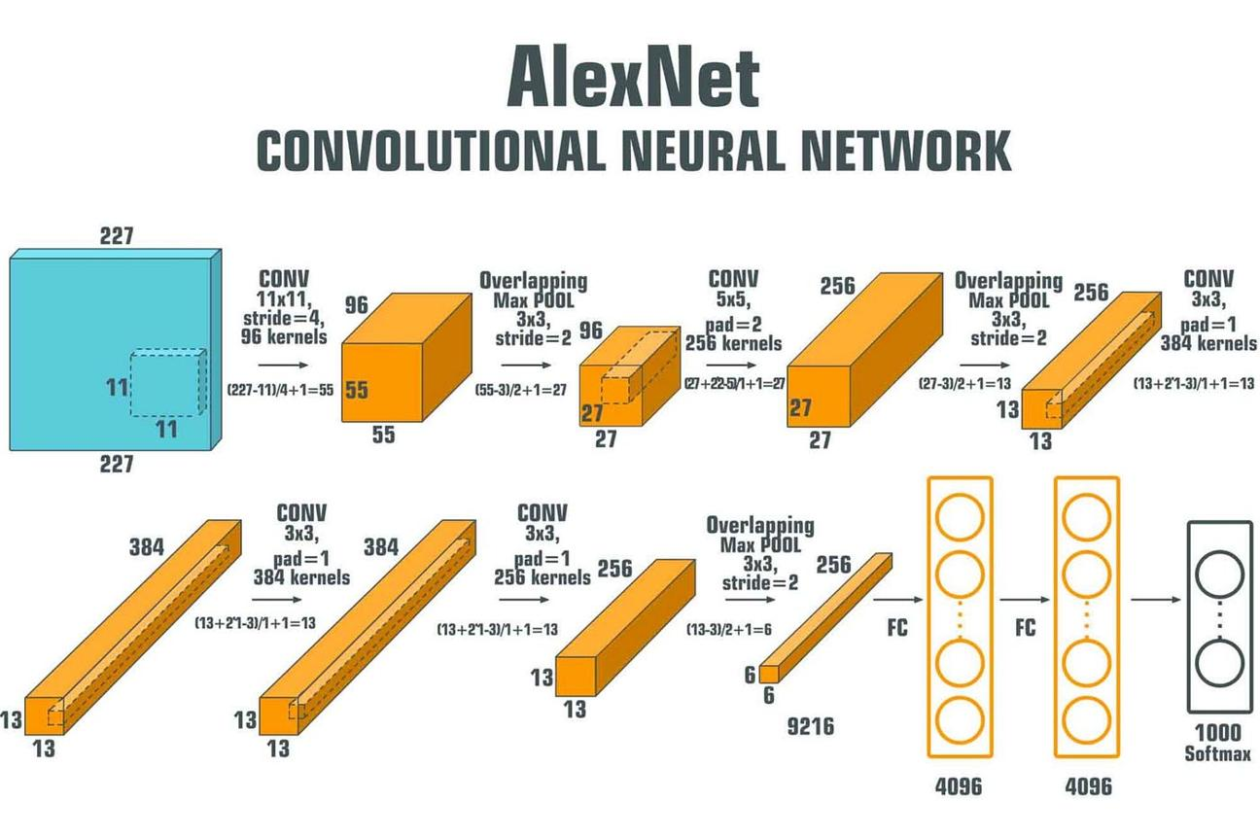
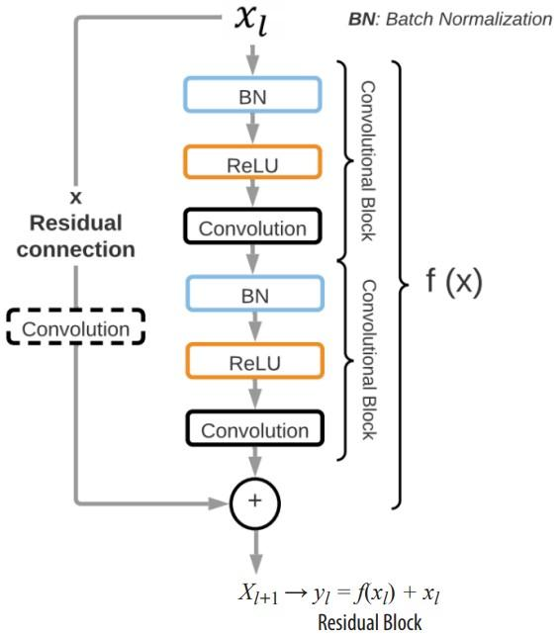

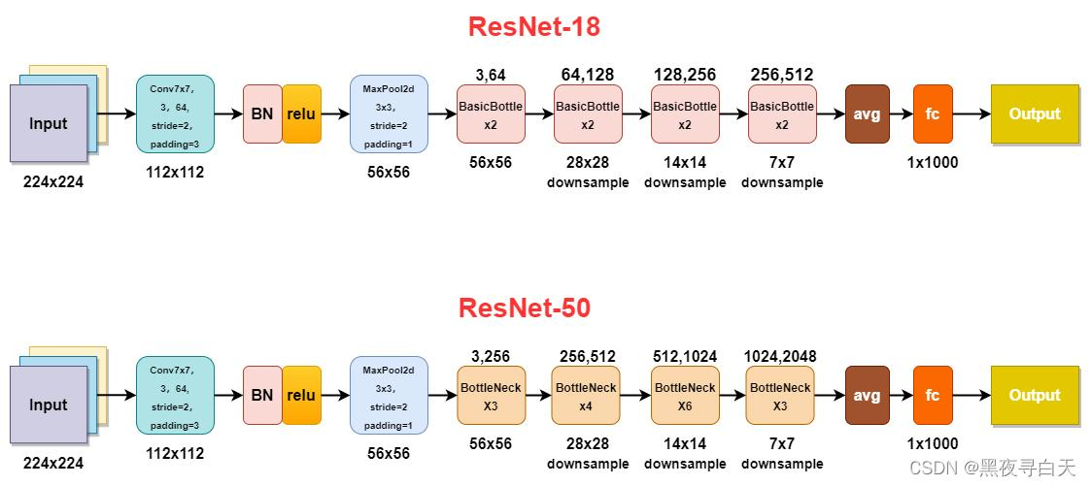

1. Network Depth
AlexNet is a relatively shallow CNN compared with modern architectures. It contains several convolutional and fully connected layers.
ResNet can have much greater depth, such as:
- ResNet-18
- ResNet-34
- ResNet-50
- ResNet-101
- ResNet-152
The larger depth allows ResNet to learn increasingly complex hierarchical features.
2. Layer Organization
AlexNet uses a straightforward sequence:
Convolution → Activation → Pooling → Fully Connected
ResNet introduces residual blocks.
A residual block allows the input to bypass one or more layers through a shortcut connection.
Conceptually:
where:
- = original input
- = transformation learned by the convolutional layers
- = residual output
3. Vanishing Gradient Problem
As networks become deeper, gradients may become very small during backpropagation. This is known as the vanishing-gradient problem.
It makes very deep networks difficult to train.
ResNet addresses this using skip/shortcut connections, which provide an easier path for gradient propagation.
Therefore, ResNet can successfully train much deeper networks.
4. Feature Extraction
AlexNet learns features from:
- Edges
- Textures
- Shapes
- Object patterns
ResNet also performs hierarchical feature extraction but can learn significantly more complex representations due to its greater depth.
5. Parameter Requirements
AlexNet has a relatively large number of parameters, especially because of its fully connected layers.
ResNet's parameter count depends on the variant. Interestingly, deeper ResNet versions can be parameter-efficient because architectures such as ResNet-50 use bottleneck blocks.
Therefore, depth alone does not determine parameter count.
6. Training Difficulty
AlexNet is easier to understand and train because it is comparatively simple.
A very deep conventional network can be difficult to optimize.
ResNet makes deep training easier through residual connections.
7. Computational Cost
AlexNet generally requires less computation than very deep ResNet variants.
ResNet-50, ResNet-101, and ResNet-152 require more computation than AlexNet, but they generally provide much stronger feature representations.
The exact cost depends on:
- Input resolution
- ResNet version
- Batch size
- Hardware
- Number of operations
8. Comparison
Feature | AlexNet | ResNet
Depth | Relatively shallow | Very deep
Main innovation | Deep CNN with ReLU, pooling and large-scale image classification | Residual/skip connections
Feature learning | Good | More powerful
Skip connections | No | Yes
Very deep training | Difficult | Much easier
Vanishing gradient | More problematic | Significantly reduced
Parameters | Large, especially FC layers | Depends on variant
Computational cost | Lower than deep ResNets | Higher for deeper variants
Complex recognition | Good | Excellent
Modern applications | Limited compared with newer architectures | Widely used
9. Recommendation
For a complex image recognition application, ResNet is generally the better choice.
The main reasons are:
- It supports very deep networks.
- Residual connections improve gradient propagation.
- It learns complex hierarchical features.
- It generally provides stronger image recognition performance.
- It is more scalable for complex computer vision tasks.
AlexNet is historically important and useful for understanding the development of CNNs, but ResNet is generally more appropriate for demanding modern image recognition applications.

Q5. Regularized CNN vs Non-Regularized CNN
The agricultural organization observes very high training accuracy but poor performance on unseen leaf images. This is a classic indication of overfitting.
Overfitting occurs when the CNN learns the training images too specifically instead of learning general patterns associated with plant diseases.
For example, the model might memorize:
- Background patterns
- Lighting conditions
- Specific leaf positions
- Image noise
- Individual training examples
instead of learning the actual disease characteristics.
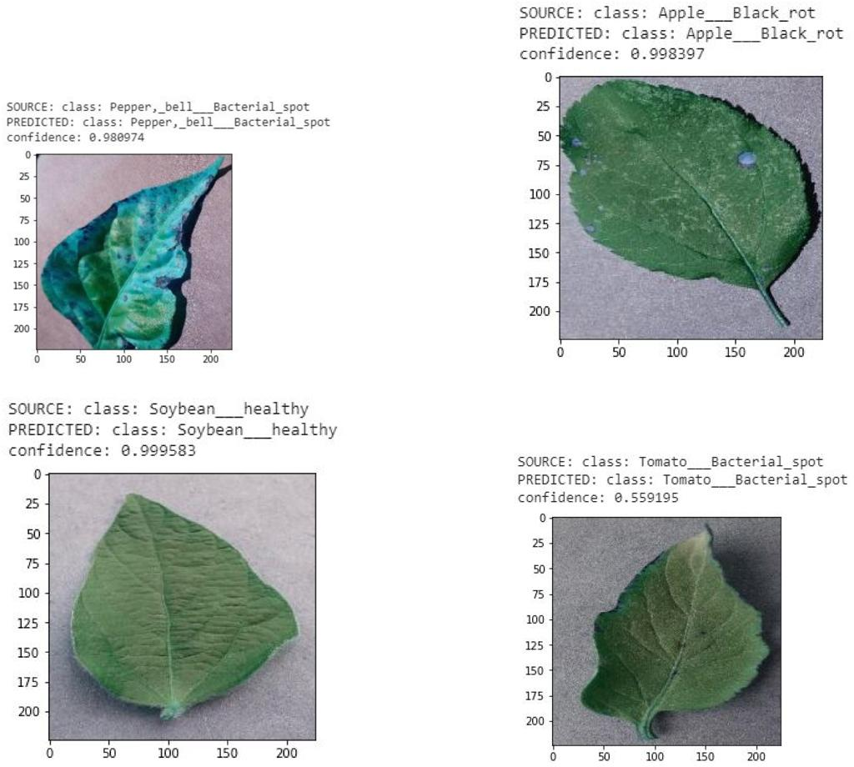
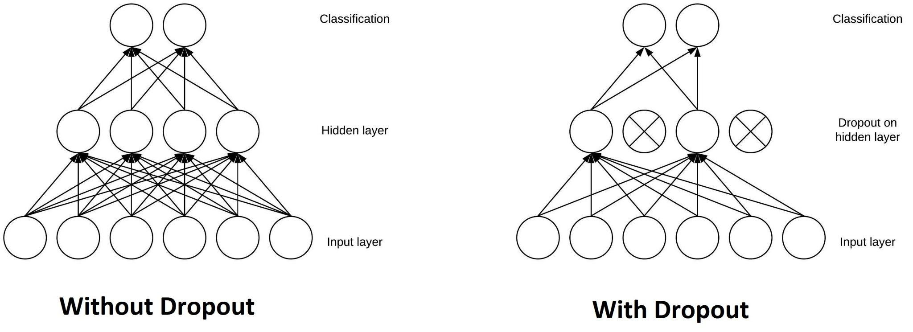
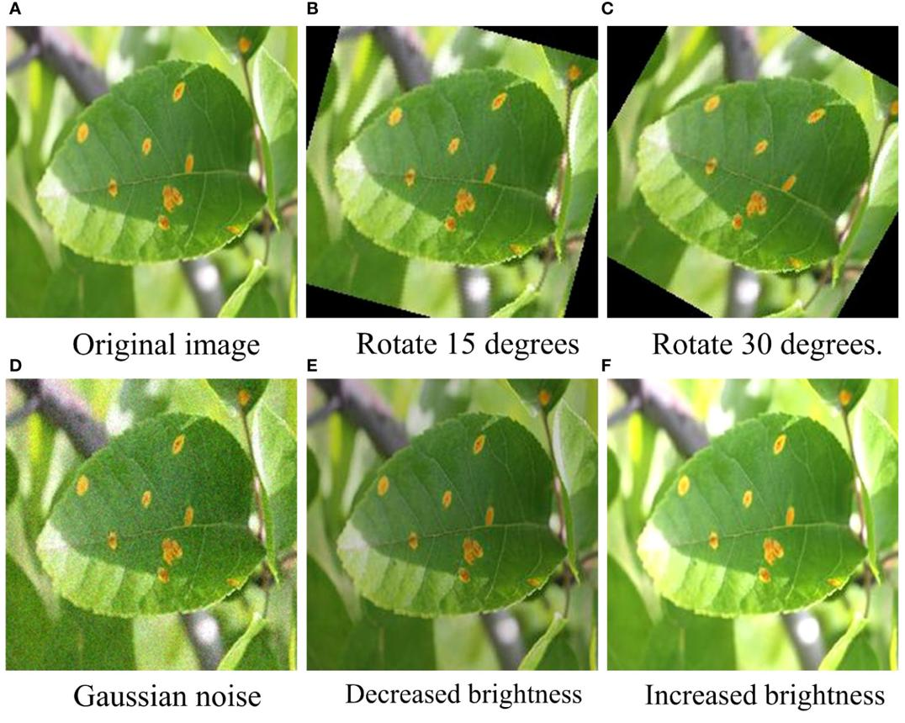

1. CNN Without Regularization
A non-regularized CNN may have:
- Very high training accuracy
- Low training loss
- Poor validation accuracy
- Poor test accuracy
This means the model performs well on known examples but fails to generalize.
For example:
Training accuracy = 98%
Testing accuracy = 70%
This large difference indicates potential overfitting.
2. Dropout
Dropout randomly disables a proportion of neurons during training.
For example, with a dropout rate of 0.5, approximately half of the selected activations are randomly dropped during a training step.
This prevents the network from depending too heavily on particular neurons.
Benefits:
- Reduces overfitting
- Encourages distributed feature learning
- Improves generalization
However, too much dropout can make learning slower or cause underfitting.
3. Data Augmentation
Data augmentation creates modified versions of existing training images.
For plant leaves, suitable transformations may include:
- Rotation
- Horizontal flipping
- Small translations
- Zooming
- Cropping
- Brightness variation
- Contrast variation
For example, one leaf image can produce several realistic training variations.
This increases the effective diversity of the dataset.
Why is this important?
Real agricultural images may be captured under:
- Different sunlight
- Different camera angles
- Different distances
- Different backgrounds
- Different leaf orientations
Data augmentation helps the model become more robust to these variations.
4. Batch Normalization
Batch normalization normalizes intermediate activations during training.
It can:
- Improve training stability
- Allow more stable optimization
- Often speed up training
- Help the network train effectively with deeper architectures
Batch normalization is primarily an optimization technique rather than a traditional regularizer, although it can also have a regularizing effect.
5. Comparison
Feature | Without Regularization | With Regularization
Training accuracy | Often very high | Usually high
Test accuracy | Often lower | Usually improved
Overfitting | High risk | Reduced
Generalization | Poorer | Better
Dropout | Not used | Reduces neuron dependency
Data augmentation | Not used | Increases data diversity
Batch normalization | Not used | Improves training stability
Real-world reliability | Lower | Higher
6. Which Techniques Should Be Applied?
For plant disease classification, a combination of techniques is preferable.
Data Augmentation
This should be strongly considered because agricultural images naturally vary in orientation, lighting, scale, and background.
Dropout
Dropout can be applied, particularly around the classification portion of the network, when the model is overfitting.
Batch Normalization
Batch normalization can be included in convolutional blocks to improve training stability and optimization.
Additional Measures
Other useful techniques include:
- Early stopping
- Weight decay/L2 regularization
- Transfer learning
- Cross-validation where appropriate
- Monitoring validation loss
- Collecting more diverse images
7. Recommended Approach
A practical architecture could follow:
Leaf Image
↓
Data Augmentation
↓
Convolution
↓
Batch Normalization
↓
ReLU
↓
Pooling
↓
More Convolutional Blocks
↓
Dropout
↓
Classification Layer
↓
Disease Prediction
The training process should monitor validation performance, not only training accuracy.
For example:
Model | Training Accuracy | Validation Accuracy | Interpretation
No regularization | 98% | 69% | Strong overfitting
With augmentation | 94% | 82% | Better generalization
Augmentation + dropout | 92% | 86% | Reduced overfitting
Augmentation + dropout + BN | 93% | 88% | More stable and generalized
These values are illustrative, not experimental results.
Conclusion
The regularized CNN is more appropriate for real-world plant disease classification. Data augmentation increases the diversity of training examples, dropout reduces dependence on specific neurons, and batch normalization improves training stability. These techniques together can reduce overfitting and improve generalization to unseen leaf images.
Overall recommendation: For a real agricultural deployment, use data augmentation + suitable batch normalization + moderate dropout, while monitoring validation performance and using early stopping when necessary. This provides a better balance between training accuracy, generalization, computational cost, and reliability.

